**FILTEK FILTERCART FC-2**

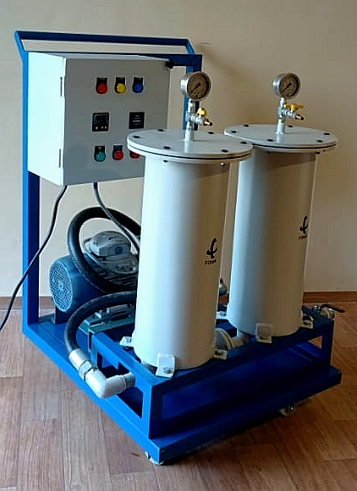 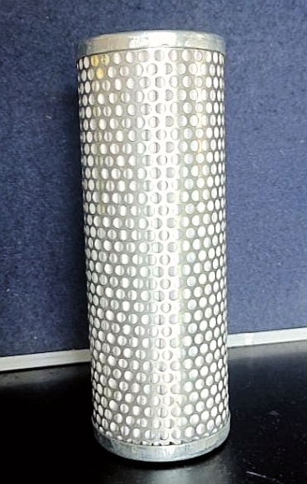 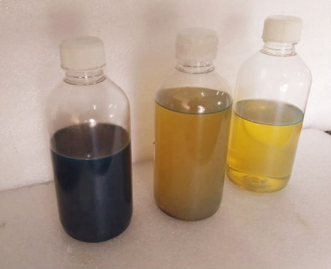

Filtration Skid FC-2 MicroGlass Cartridge Filtration Quality

Filtek standard FC-2 Skid consists of 1 x 10 micron + 1 x 5-1 micron, microglass pleated cartridges of 70X150x450mm along with 1 HP motor & 30 LPM pump with control panel all mounted on a portable trolley with castors. The micron rating of the filter cartridges can be changed based on the application and user requirement. Depending on the required flow rate required we can configure the filters in either series or parallel. In the event of moisture in oil, we also offer a patented water absorbing 5 micron cartridge with 2.7 litres water holding capacity per cartridge. Skid dimensions are 870x700x1170mm(LBH). The Control Panel consists of RYG phase indicators, Pump ON / OFF, Motor Trip and Hourmeter & Timer.

Applications:

* Hydraulic Power Press
* Cranes/Winches
* Machine Tool
* Earthmoving Equipment
* Cement and Steel Industry
* Stored Hydraulic/Engine/Gearbox/HSD/LDO
* Diesel Oil Filtration
* Oil Cleaning Services
* Marine Industry / Oil Rigs

